**SQUAD Dataset Statistical Analysis**

|  |  |  |  |
| --- | --- | --- | --- |
| **S.no** | **Aspect** | **Train set** | **Test set** |
| 1 | Total word count | 91,87,544 | 10,93,051 |
| 2 | Total Question count | 87,599 | 10,570 |
| 3 | Context count | 18,896 | 2,067 |
| 4 | Avg Question length | 10.46 | 10.82 |
| 5 | Avg Answer length | 3.26 | 3.15 |
| 6 | Avg Context length | 117 | 123 |
| 7 | Avg Question count per context | 4.64 | 5.11 |

**Training Set charts**

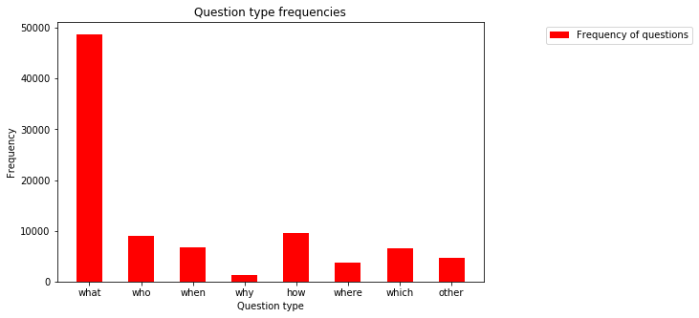

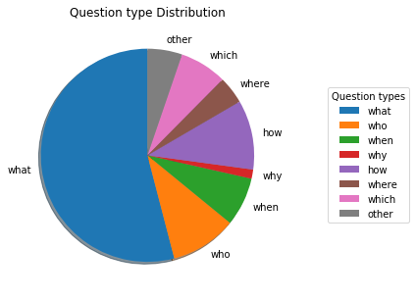

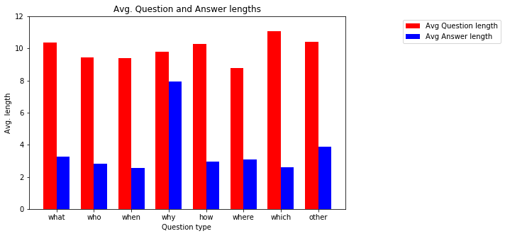

**Test Set charts**

